***EQUIFAX***

CMS Fusion

**INPUT PROCESS**

**DOCUMENTATION**

Table of Contents

Input Tab 2

1. Import New File 3

2. Layout Search 6

3. Layout Definition 7

4. Run Data check 8

5. Summary 9

**Revision History**

| **Revision** | **Author** | **Date** | **Status and Description** |
| --- | --- | --- | --- |
| 1.0 | UST Global | 11/01/2017 | Initial Draft |
| 1.1 | Equifax | 11/15/2017 | Review |
| 2.0 | UST Global | 11/17/2017 | Review Comments Incorporated |

# Input Tab

Customers will be providing the details of the files for getting processed within the fusion for getting the credit details. These files will be added in a ‘nas’ location, which is a server space where these files are stored. These files will be imported to Fusion app and processing is done to get data from Data Pump. Import Zips is to create a list of individual zips to Data Pump job.

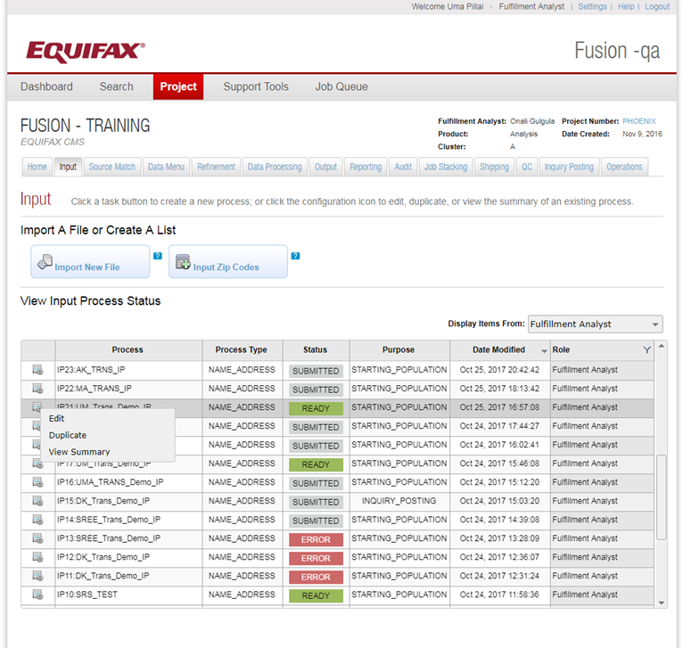

## View Input Process Status

While clicking on the input tab, it will list the set of Input processes created for the project and its details

* Process – The Process name used for the process.
* Process Type – Type of process.
* Status – The status of the process created.
* Role – Represents different roles in the application. – Fulfilment Analyst, Programmers.

These will be the role of users who created the process.

* Display Item From - Filters the list of input files based on the role, who created the Input process.
* Edit – If need to edit any option provided in the process before submitting.
* Duplicate – Provides an option to duplicate an existing process.
* View Summary – There is a high level view of what all options are selected for the process.

## Import New File

This Wizard helps to add the options to import a file.

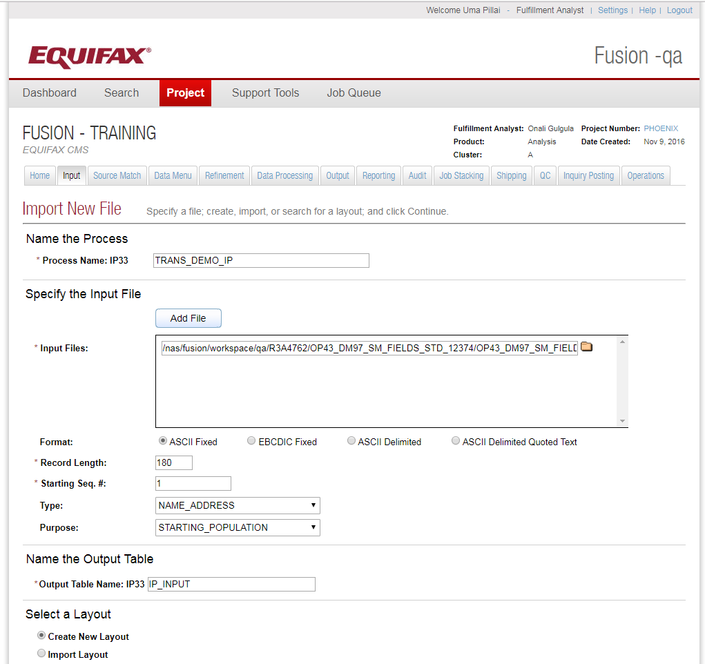

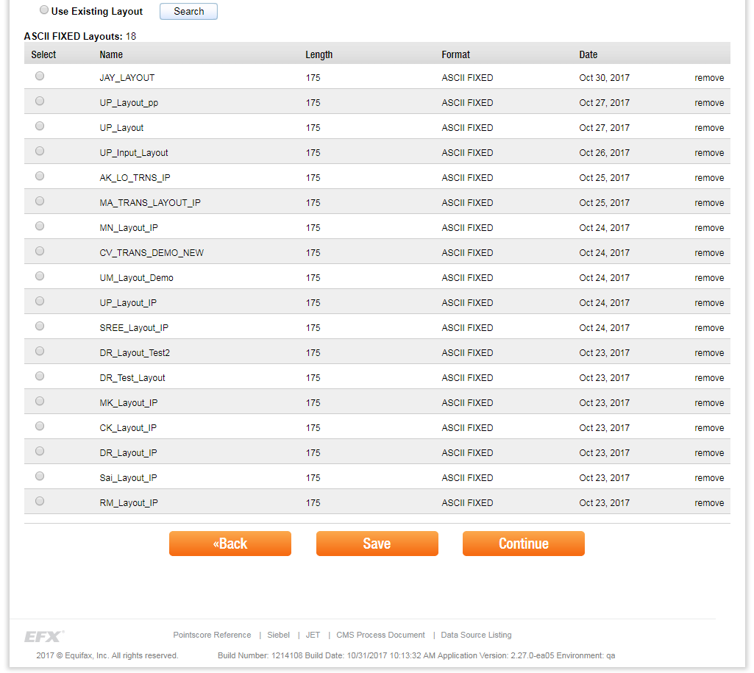

## Name the process

**Process Name:** A process name has a Process Id which is an Auto Generated Id. This will prefix the Process Name that is provided. In the screenshot above Process Id is IP33 and Process Name is TRANS_DEMO_IP. So the process Name would be IP33: TRANS_DEMO_IP.

## Specify the input file

**Input File:** Import the input file from the ‘nas’ location, which is a server location. We can import multiple files of same format as input for a process. Files can be viewed using a file viewer tool, which will chunk the large files so that each chunk can be viewed separately.

**Sample Input file:** */nas/fusion/workspace/qa/R3A4762/OP43_DM97_SM_FIELDS_STD_12374/OP43_DM97_SM_FIELDS_STD/I26288_OT_COMBINEFILE/ALL_REC.fixed*

**Format:** This represents the format of the file that is provided as the input. The file formats can be ASCII, ASCII Delimited, EBCDIC, ASCII Delimited Quoted Text.

* EBCDIC is the mainframe file format.
* ASCII Delimited format will contain the inputs separated by a delimiter (Eg. Comma, Tab, Space, Colon, Semicolon , Pipe).
* ASCII Delimited Quoted Text format will contain the inputs separated by a delimiter, but there can be other special characters in between the fields. For eg. Name can have some special characters. (Eg. Comma, Tab, Space, Colon, Semicolon , Pipe).

**Record Length:** Length of the input record.

**Sequence Number:** It is a unique number which identifies the record. This will continue while taking the record from the second file. So the sequence number of the second file will be the continuation of the sequence number from the first file.

**Type:** Contains the information about the input file. It would specify what the input file contains. So the input file can contain Name and address or CID or SSN etc. This is used to tag or let the user know what the input file contains.

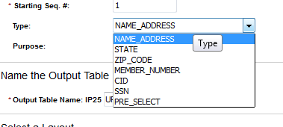

**Purpose:** This field provides information on what the file is used for.

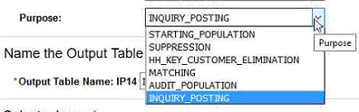

## Name the Output Table

Logical name of table in Green Plum, where the Input fields are stored.

## Select a Layout

* Create layout – creates a new layout.
* Import Layout – Can import a custom layout and it must be in csv.
* Use Existing – It will list the layout used within a project. We can search for a layout in other project and use that in the current project. It’s worth noting that a layout is linked to the project in which it’s used. Therefore, if you use a layout from another project, a copy of that layout will be made and linked to the current project.

## Layout Search

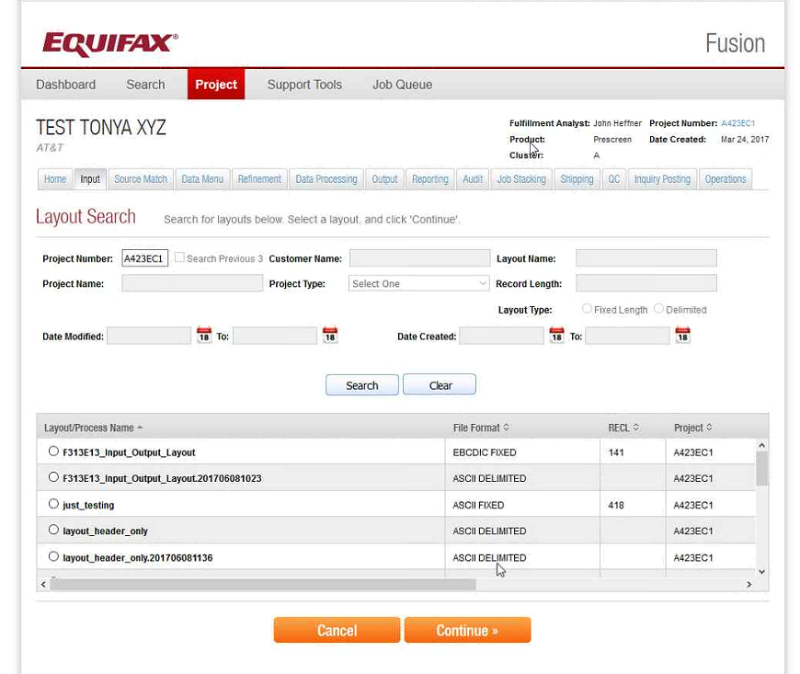

**Continue:** By selecting a layout and clicking Continue, a copy of that layout is made and linked to the current project. Only a reference to the layout would be stored with the process configuration.

## Layout Definition

Here we can define a layout for the input file.

**The Column Selection and Header Rows:** The Column selection controls how the UI will behave. When you have the Column Selection set to Start, each mark made in the preview indicates the starting position of a field (column). When set to End, each mark indicates the ending position of a field (column). When set to Sequential Columns, each mark denotes the end of the field to its left, and the next field begins in the first byte to its right. Header Rows is used to indicate whether or not the file contains header records that should be omitted when the file is imported. Yes, there is a preview of the file which displays the first and last five records. For EBCDIC files, the file contents are shown with the display value (character) on top of the corresponding hex value. ASCII files only show the display value. These fields will specify how the new layout should be. There is a Doc view which represents the first five and last five records of the file. With the selection in the Column Selection, we can specify the start and end of the columns. It also contains the Hex representation of the data.

**Name the Data Fields:** This would specify the field types and names for the inputs in the Database. We can specify the data type start and end etc for the Fields that need to be inserted into the database. GreenPlum will store the data in ASCII format.

The Generate Positions Table button inserts a row into the Layout Fields table for each field defined in the file preview. 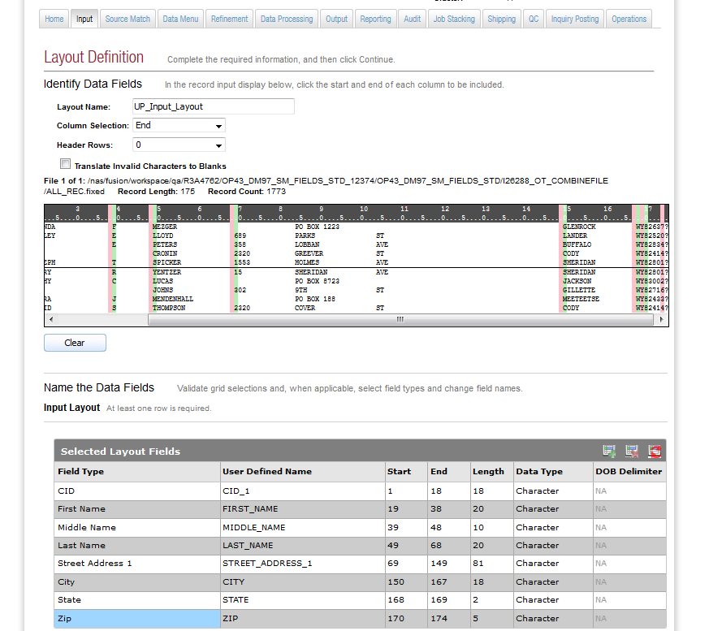

**Add Column:** Add a constant into Green Plum Database. Add a value to every record.

Example: If more than one file, we can tag from which file the data come from. In the below, all data from ALL_REC.fixed is having an additional field in ‘UP_INPUT’, than mentioned in the fields, and its value will be A. ‘Tag’ is the field name in the Database.

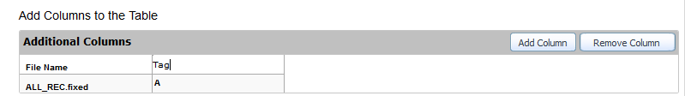

## Run Data check

Run Data Check is used for field validations against input fields . It will compare the datatype of fields with the datatype in the layout selected. It can analyze, if every record is blank or it contains any unprintable characters. File Identifier is an option to create a unique identifier name to the generated file.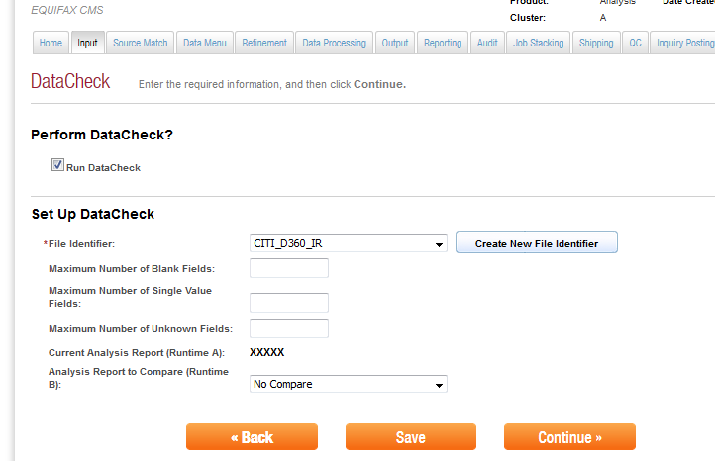

## Summary

This page shows the summary of the process we have created. It will show the layout and other options that are selected for the process. Once we click Submit button, no change can be made to the process. The output of the process would be saved in Green Plum database.

